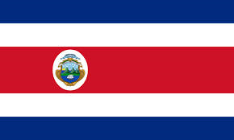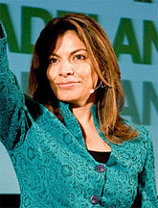

**Government Officials:**

The Costa Rica government is set up with one president, two vice presidents, 20 member cabinet, and 57 Legislative Assembly deputies.

**The President**

The president of Costa Rica is Laura Chinchilla (picture above). She has been the president of Costa Rica since May 2010. The president of Costa Rica gets one term of four years to lead the country.

# Government of Costa Rica

**Background**

Costa Rica was first discovered by Columbus in 1502. At first the Spanish conquered Costa Rica until 1848 when it became a republic. Costa Rica is now a Democratic Republic.